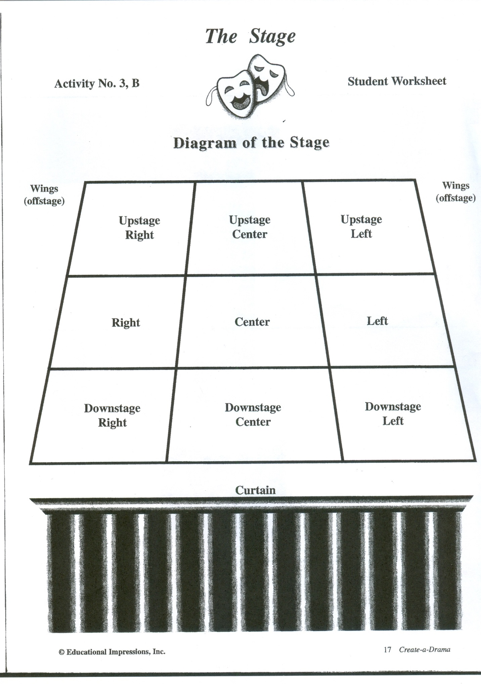

Left Wing

Right Wing

Forensics Vocabulary

Name: __________________________________________