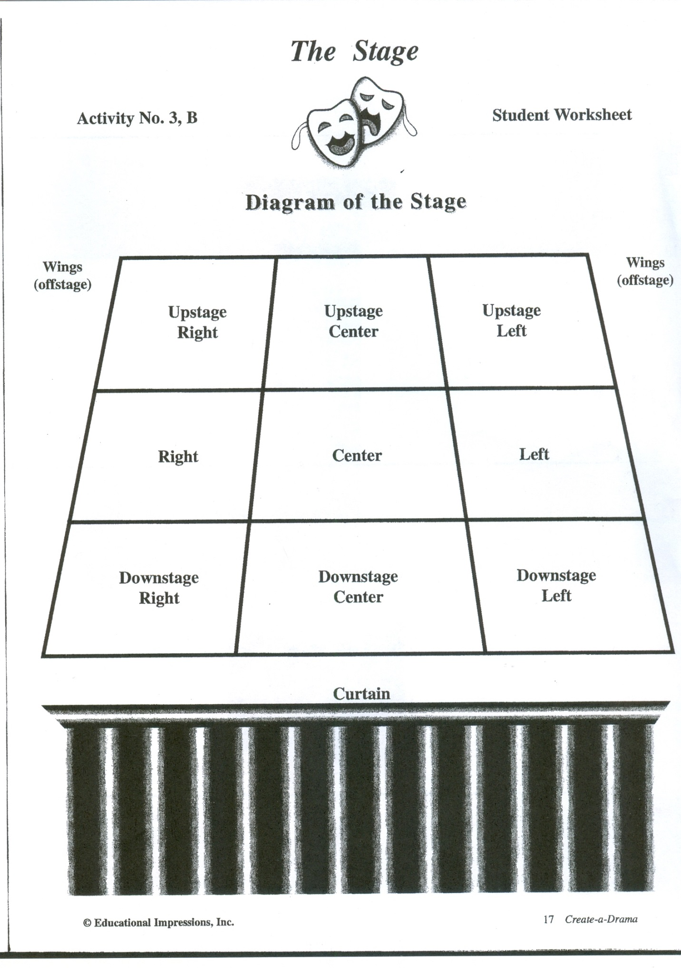

Right Wing

Left Wing

Back Wall

Name: __________________________________________