What lights do we have at Computech?

Striplights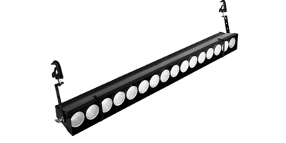  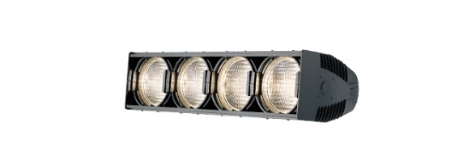 | Striplights (also known as borderlights) are compartmented fixtures designed for use as a general wash of light, usually on cycloramas or backdrops. They are usually available wired for either three or four circuit operation with multiple lamps per circuit. Striplights can use both gel and glass roundels.
Floodlights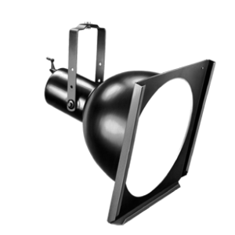  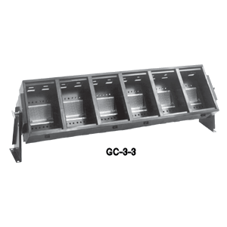 | Floodlights produce a very soft, very wide field, typically without lenses. Specialized floodlights combining two or more compartments in one fixture are known as cyc lights, as they are usually used to light cycloramas and other backdrops.

