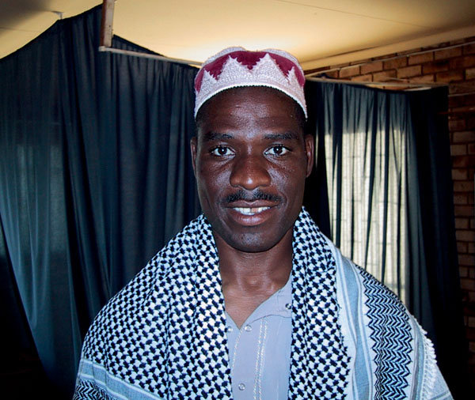
Fidelma O’Leary
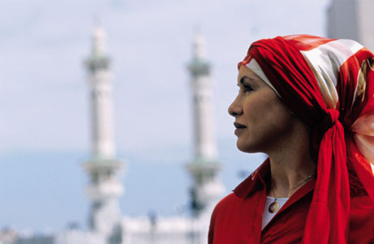


Khalil Mandhlazi

Ismail Mahbob

What do a successful executive from suburban Malaysia, a religious radio commentator from rural South Africa and an Irish-born college professor from the United States have in common? They’re all about to embark on the spiritual journey of a lifetime — the sacred Islamic pilgrimage to Mecca known as the hajj.
With privileged access to Islam’s holiest city, NATIONAL GEOGRAPHIC follows these three Muslims from different backgrounds as they embark on an epic five-day reaffirmation of faith and quest for salvation. “Inside Mecca,” captures the look and feel, spiritual uplift, claustrophobia, grandeur and grit of the largest annual gathering of Muslims in the world.
“Inside Mecca” intimately documents the pilgrimages of Fidelma O’Leary, Ismail Mahbob and Khalil Mandhlazi, beginning with their preparations at home and carrying through to the climactic events of the hajj itself. For each, the journey presents a unique challenge.
Mahbob, a successful Malaysian businessman, must leave behind his family and the material comforts to which he is accustomed in exchange for the austere lifestyle of a pilgrim.
Mandhlazi, who takes to the radio each week to bring the teachings of Islam to his fellow South Africans, seeks a chance to see an ideal world of Islam in action, yet finds that even Mecca is not free from economic and racial discord.
O’Leary, a blonde, green-eyed woman with a faint Irish lilt, she hardly looks the part of the stereotypical Muslim. Born in Ireland to a devout Catholic family, O’Leary converted to Islam while in college. Now, she embarks on hajj having fully embraced the faith, but there are moments when it seems her fellow pilgrims have difficulty accepting her as a peer.
Since hajj calls for a state of ritual sanctity and mental purity, pilgrims must be patient and persevere, not letting themselves be swayed by anger or frustration. Despite the physical and emotional challenges that each pilgrim faces on hajj, the spiritual rewards of performing the pilgrimage prevail.
Part of Mecca’s mystique stems from the fact that non-Muslims are strictly prohibited from entering the city. For this reason, very few non-Muslims have ever witnessed the rites and rituals of the hajj.

