Henry VIII and his Six Wives
Henry was king of _______________________________________________
First wife: _____________________________________________________
- How he got rid of her _______________________________________
- Children __________________________________________________
- Nationality of wife _________________________________________
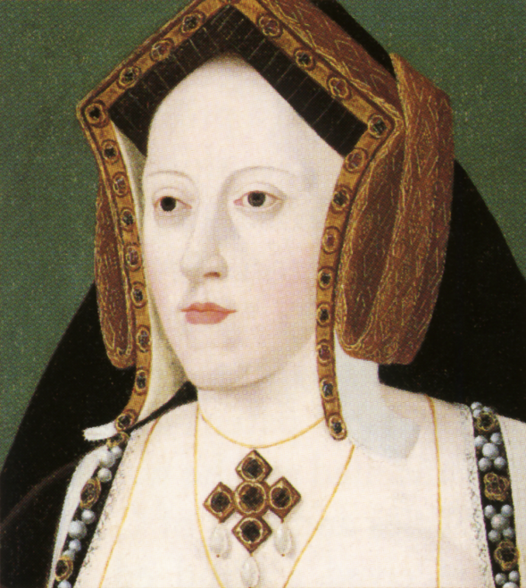
- Notes _____________________________________________________________________________________________________________________________________________________________________________________________________________________________________________________________________________________________________________________________________________________________________________________________________________________________________________________________________________________________________________________
Second wife: ___________________________________________________
- How he got rid of her _______________________________________
- Children __________________________________________________
- Nationality of wife _________________________________________
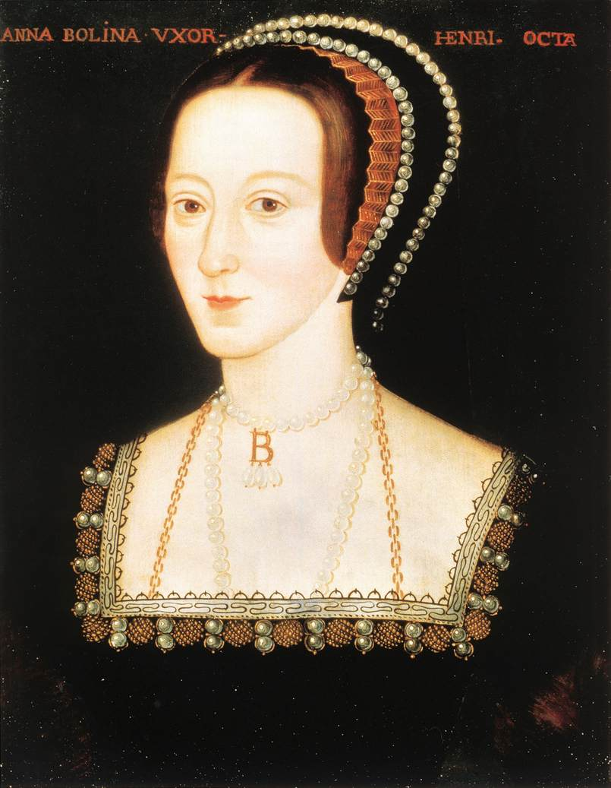
- Notes _____________________________________________________________________________________________________________________________________________________________________________________________________________________________________________________________________________________________________________________________________________________________________________________________________________________________________________________________________________________________________________________________________________________________________________________________________________________________________________
Third wife: ____________________________________________________
- How he got rid of her _______________________________________
- Children __________________________________________________
- Nationality of wife _________________________________________
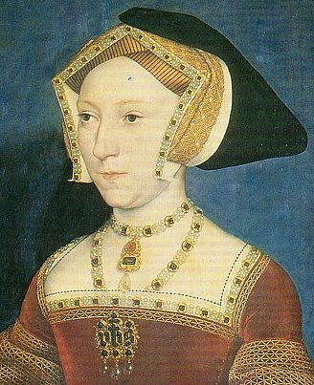
- Notes _______________________________________________________________________________________________________________________________________________________________________________________________________________________________________________________________________________________________________________________________________________________________________________________________________________________________________________________________________________________________________________________________________________________________________________________________________________________________________

Fourth wife: ___________________________________________________
- How he got rid of her _______________________________________
- Children __________________________________________________
- Nationality of wife _________________________________________
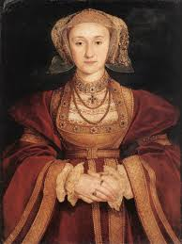
- Notes ______________________________________________________________________________________________________________________________________________________________________________________________________________________________________________________________________________________________________________________________________________________________________________________________________________________________________________________________________________________________________________________________________________________________________________
Fifth wife: _____________________________________________________
- How he got rid of her _______________________________________
- Children __________________________________________________
- Nationality of wife _________________________________________
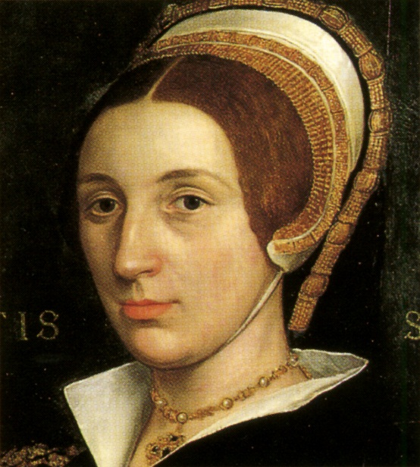
- Notes _______________________________________________________________________________________________________________________________________________________________________________________________________________________________________________________________________________________________________________________________________________________________________________________________________________________________________________________________________________________________________________________________________________________________________________________________________________________________________________________

Sixth wife: _____________________________________________________
- How he got rid of her _______________________________________
- Children __________________________________________________
- Nationality of wife _________________________________________
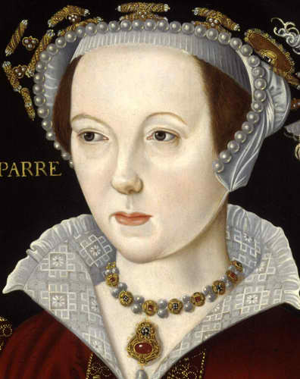
- Notes ______________________________________________________________________________________________________________________________________________________________________________________________________________________________________________________________________________________________________________________________________________________________________________________________________________________________________________________________________________________________________________________________________________________________________________

