Vice President
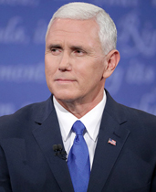

Mike Pence
Bio: Vice President-elect has a long record of public service. Referring to himself as "a Christian, a conservative, and a Republican, in that order," Pence was first elected to the U.S. House of Representatives in 2000. In 2013, he became the 50th Governor if the state of Indiana.
Prior to his career in politics, Pence worked an attorney and talk radio host.

Secretary of State
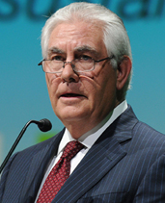

Rex Tillerson
Bio: Rex Wayne Tillerson is the Chairman and CEO of US oil and gas corporation ExxonMobil, having taken the company over in 2006. Tillerson, a native of Texas, has been with the company since 1975.
Despite his lack of official government experience, Mr. Tillerson does have experience dealing with foreign governments, as Exxon Mobil operates in dozens of countries.
Senate Hearing: Jan. 11, 9:15 A.M.
The president and chief executive of Exxon Mobil would oversee a department that has centered on alliance building and globalism, which Mr. Trump has said he would dismantle.
Mr. Tillerson was sharply questioned on his views on Russia, where he has had close business ties. He expressed reservations on climate change and said that he did not view it as the imminent national security threat that some others did.

Attorney General
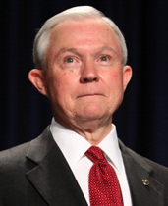
Senator Jeff Sessions
Bio: Jefferson Beauregard "Jeff" Sessions III currently serves as U.S. Senator from Alabama. Prior to his career in the U.S. Senate, Sessions was the U.S. Attorney for the Southern District of Alabama, having been appointed by then-President Ronald Reagen. Sessions was elected Attorney General of Alabama in 1994 before being elected to the United States Senate in 1996.
Senate Hearing: Jan. 10-11, 9:30 A.M.
The senator from Alabama supports strict immigration enforcement and measures tough on crime. He would be responsible for carrying out Mr. Trump's “law and order” platform and could change how civil rights laws are enforced.
During the first day of his hearing, Mr. Sessions said that the law “absolutely” prohibits waterboarding, and he offered no hints about a workaround to reinstate it. On the second day, testimony from Representative John Lewis, a Georgia Democrat and civil rights leader, highlighted the racial undertones of Mr. Sessions’s nomination.

Secretary Of Defense


Gen. James Mattis
Bio: General James Mattis is a 44-year veteran of the United States Marine Corps. Mattis brings with him a wealth of experience having served as commander of United States Central Command from August of 2010 to March of 2013, replacing General David Petraeus.
Mattis is beloved by the men who served under him, and earned the nickname "Warrior Monk" for a ferocious yet intellectual approach to leadership.
Confirmed by Senate: 98-1
The retired general would shape the fight against the Islamic State while overseeing a military that is struggling to put in place two Obama-era initiatives: integrating women into combat roles and allowing transgender people to serve openly.
General Mattis diverged from Mr. Trump on several issues during his hearing, striking a tougher stance on Russia and a more supportive one on NATO and saying that he supported the Iran nuclear agreement.

Secretary of Homeland Security
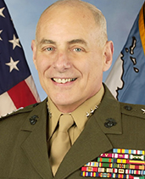

Gen. John Kelly
Bio: General Kelly is a distinguished military commander who is a widely respected by both his troops and Washington insiders.
With decades of experience leading U.S. Armed Forces, Kelly is a veteran of both Operation Desert Storm and Operation Iraqi Freedom. The retired general served as commander of United States Southern Command from November of 2012 until January of 2016.
Confirmed by Senate: 88-11
If Mr. Trump makes good on his promises of widespread deportations and building a wall, the retired four-star Marine general will be responsible for carrying them out.
During his remarkably subdued hearing, General Kelly appeared to put concerns to rest over Mr. Trump’s more contentious stances, like forcing Muslims to register with the federal government.

Secretary of the Treasury

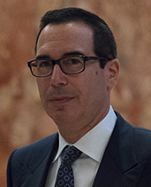

Steven Mnuchin
Bio: Steven "Steve" Mnuchin is a successful banker. Prior to being tapped to lead the U.S. Treasury, Mnuchin was chief executive of Dune Capital Management, a privately owned hedge fund, and was a partner at Goldman-Sachs for 17-years.
Mnuchin served as the Trump campaign finance chairman

Secretary of Labor

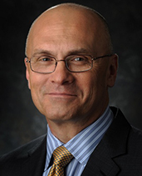

Andy Puzder
Bio: Andy Puzder is the chief executive of CKE Restaurants, which include the Carl's Jr./Hardee's chains.
Prior to his career as CEO, Puzder was a commercial trial lawyer in St. Louis. From 1978 through 1983, he was an associate at the law offices of St. Louis attorney Morris Shenker who he represented in various matters. In 1984 he moved to The Stolar Partnership in St. Louis and worked with Charles A Seigel, another St. Louis area trial attorney. Puzder has served as president and CEO of CKE since September 2000.

Secretary of Commerce

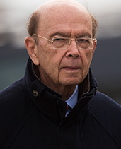

Wilbur Ross
Bio: Wilbur Ross is a successful American investor and business man. Ross is known as a "turnaround artist" who has acquired failing businesses and made them profitable.
Although a registered Democrat, Ross an early supporter of Donald Trump's presidential campaign.
Senate Hearing: Jan. 18, 10 A.M.
The investor, whose fortune is estimated by Forbes at $2.9 billion, has said the United States must free itself from the “bondage” of “bad trade agreements,” and has advocated threats to impose steep tariffs on China.
During his hearing, Mr. Ross said he would prioritize making sweeping changes to the North American Free Trade Agreement, one of Mr. Trump's campaign promises.

Secretary of Veterans Affairs

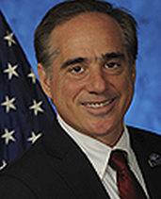

Dr.David Shulkin
Bio:Dr. Shulkin currently serves as Under Secretary of Health for the U.S. Department of Veterans Affairs. Prior to joining the VA, Dr. Shulkin worked as board-certified internist, a was a fellow of the American College of Physicians.
Shulkin would be the first Secretary of the VA who is not a veteran of the U.S. armed forces.

Secretary of the Interior

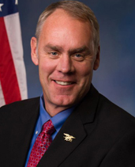

Ryan Zinke
Bio: Rep. Ryan Zinke represents the state of Montana in the U.S. House of Representatives.
Prior to his career in politics, Zinke was a U.S. Navy SEAL. In 2004, Zinke was named the deputy and acting commander of Combined Joint Special Operations Task Force–Arabian Peninsula and commanded 3,500 special operations personnel during Operation Iraqi Freedom. He retired from the Navy at the rank of commander in 2008.
Senate Hearing: Jan. 17, 10 A.M.
The representative from Montana and onetime Navy SEAL commander would decide the fate of Obama-era rules that stop public land development; curb the exploration of oil, coal and gas; and promote wind and solar power on public lands.
When asked about climate change during his hearing, Mr. Zinke broke with Mr. Trump, saying that he did not believe it was a hoax.

Secretary Of Energy
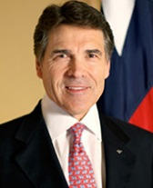

Rick Perry
Bio: Rick Perry is the longest serving Governor in Texas history, having served as the state's chief executive from 2000-2015.
Prior to serving as Governor, Perry was a member of the Texas House of Representatives, a capacity in which he served until 1991 when he was elected Texas agriculture commissioner. In 1999, Perry became Lt. Governor of Texas under George W. Bush, whom he succeeded when Bush was elected president.
Senate Hearing: Jan. 19, 10 A.M.
The former Texas governor, who in 2011 proposed scrapping the Energy Department while he was seeking the Republican nomination for president, would be responsible for protecting and managing the nation's arsenal of nuclear weapons.
During his hearing, Mr. Perry said that he regretted suggesting that the Energy Deparment be abolished, and he reversed his previous comments denying human-caused climate change, saying, "I believe some of it is naturally occurring, but some of it is also caused by man-made activity."

Secretary of Housing and Urban Development

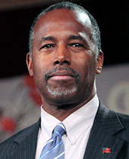

Ben Carson
Bio: Dr. Ben Carson is a retired neurosurgeon and GOP former presidential candidate.
At 33, Carson became the director of pediatric neurosurgery at Johns Hopkins Hospital and earned fame for his groundbreaking work separating conjoined twins. In 2000, the Library of Congress selected Dr. Carson as one of its "Living Legends." The following year, CNN and Time magazine named Dr. Carson as one of the nation's 20 foremost physicians and scientists.
Senate Hearing: Jan. 12, 10 A.M.
The former neurosurgeon would oversee fair-housing laws, the development of affordable housing and access to mortgage insurance. He has stressed individual effort, not government programs, as the key to overcoming poverty.
During his hearing, Mr. Carson faced pointed questions about past remarks on the dangers of federal assistance. “Safety net programs are important," he said. "I would never advocate abolishing them without having an alternative for people to follow."

Secretary of Education
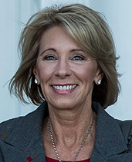

Betsy DeVos
Bio: Betsy DeVos is the chairwoman of American Federation for Children which, according to the organization's website seeks "to improve our nation’s K-12 education by advancing systemic and sustainable public policy that empowers parents, particularly those in low-income families, to choose the education they determine is best for their children."
Senate Hearing: Jan. 17, 5 P.M.
The former chairwoman of the Michigan Republican Party and an activist for school choice would oversee a department that Mr. Trump has said he wants to drastically shrink by shifting responsibilities to state and local governments.
In her highly partisan hearing, Ms. DeVos was criticized by Democrats for wanting to “privatize” public education but praised by Republicans for her support of charter schools and vouchers.

Secretary of Health and Human Services
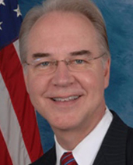

Tom Price
Bio:Congressman Tom Price has represented Georgia's 6th congressional district since 2005.
Before serving in the House of Representatives, Price was an orthopedic surgeon. Price has been instrumental in crafting legislation to replace the Affordable Care Act, and implementing such legislation would likely be amongst his first tasks as Secretary of Health and Human Services.
Senate Hearing: Jan. 18, 10 A.M., Jan. 24, 10 A.M.
Mr. Price, a Republican representative from Georgia and an orthopedic surgeon, has led the opposition to the Affordable Care Act in Congress. In this role he would help Mr. Trump achieve one of his central campaign promises: the act's repeal and replacement.
Mr. Price said in his first hearing that repealing the Affordable Care Act would not leave millions without health insurance, but he gave few details about the administration’s plans to replace the law. He will also be questioned by the Senate Finance Committee next week.

Secretary of Transportation
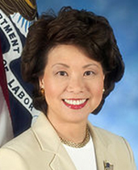

Elaine Chao
Bio: Before being chosen to serve as Donald Trump's Secretary of Transportation, Elaine Chao served as Secretary of Labor under President George W. Bush from 2001 through 2009, the first Asian-American woman to serve in a Cabinet position.
Chao has been married to Senate Majority Leader Mitch McConnell since 1993
Senate Hearing: Jan. 11, 10:15 A.M.
Ms. Chao, who was labor secretary under President George W. Bush, would oversee Mr. Trump’s campaign pledge to increase funding to rebuild America's transportation infrastructure.
Ms. Chao's nomination has faced little opposition from lawmakers. She spent most of her hearing promising to further study the issues she will oversee.

CIA Director
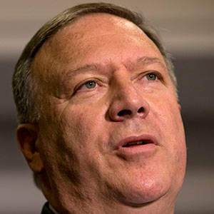
Mike Pompeo
Senate Hearing: Jan. 12, 10 A.M.
The representative from Kansas and former Army officer would have to decide whether to undo a new C.I.A. “modernization” plan, and how to proceed if Mr. Trump orders a resumption of harsh interrogation tactics for terrorism suspects.
Mr. Pompeo said that as C.I.A. director, he would pursue information about Russian interference into the American election. He said emphatically that he would not endorse torture, a reversal from past statements.

UN Ambassador
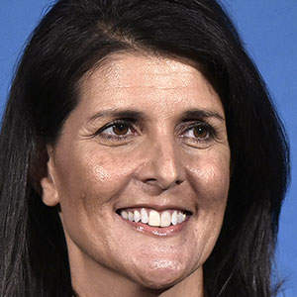
Nikki R. Haley
Senate Hearing: Jan. 18, 10 A.M.
The governor of South Carolina would be the primary face of America to the world, representing the country’s interests at the Security Council on a host of issues that include Middle East peace and nuclear proliferation.
Ms. Haley's nomination has faced little opposition from lawmakers. During her hearing, she criticized the United Nations’ relationship with Israel and said that Russia was guilty of war crimes in Syria.

EPA Administrator
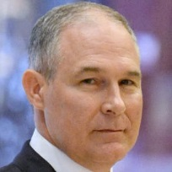
Scott Pruitt
Senate Hearing: Jan. 18, 10 A.M.
The Oklahoma attorney general is a close ally of the fossil fuel industry and has taken on the E.P.A. directly in his current job. He would oversee an agency that the president has vowed to dismantle “in almost every form.”
During his hearing, Mr. Pruitt said he disagreed with Mr. Trump’s statement that climate change was a “hoax." He criticized federal environmental regulations, emphasizing a states-based approach.

Treasury Secretary
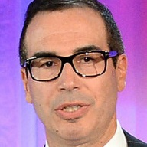
Steven Mnuchin
Senate Hearing: Jan. 19, 10 A.M.
The former Goldman Sachs executive would be responsible for government borrowing in financial markets. He would also be involved in assisting with any rewrite of the tax code and carrying out or lifting financial sanctions against foreign enemies.
Democrats on the Senate Finance Committee pressed Mr. Mnuchin on his use of offshore tax havens, his initial failure to disclose almost $100 million in assets and charges that a company he ran was overly aggressive in forclosing on homes.

Small Business Administration
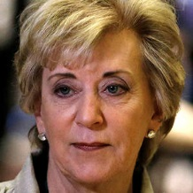
Linda McMahon
Senate Hearing: Jan. 24, 10:30 A.M.
The former chief executive of World Wrestling Entertainment would oversee an agency that guarantees loans for small businesses, helps them get government contracts and supports their interests on Capitol Hill.

Director of the Office of Management and Budget
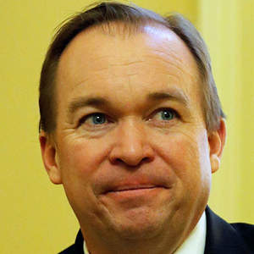
Mick Mulvaney
Senate Hearing: Jan. 24, 10:30 A.M.
The conservative representative from South Carolina, a proponent of deep spending cuts, would help provide guidance with several of Mr. Trump's priorities, including a repeal of the Affordable Care Act, a tax overhaul and large investments in infrastructure.

Labor Secretary
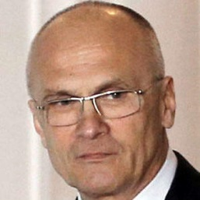
Andrew F. Puzder
Senate Hearing: Feb. 2
The chief executive of CKE Restaurants, who has criticized the Obama administration’s labor policies, would be in charge of keeping Mr. Trump’s promise to dismantle many Obama-era rules covering the vast work force of federal contractors.
Congressional Democrats, along with labor organizations and other groups, have waged a particularly aggressive campaign against Mr. Puzder, saying he has a record of rigging the system against American workers.

Director of National Intelligence
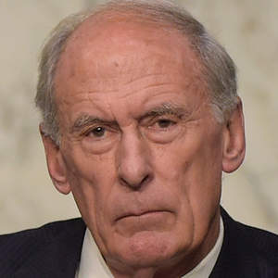
Dan Coats
Senate Hearing: T.B.D.
Mr. Coats served on the Senate intelligence and armed services committees while representing Indiana. Some in Mr. Trump's orbit believe that the job, overseeing the entire military and civilian intelligence apparatus, is superfluous.
The committee will likely confront Mr. Coats with Mr. Trump's own positions during his confirmation hearing.

U.S. Trade Representative
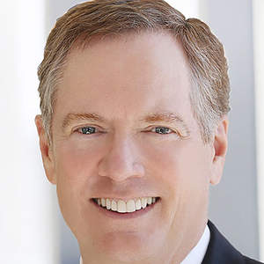
Robert Lighthizer
Senate Hearing: T.B.D.
The international lawyer served as a trade official under President Reagan. He role would include opposing new trade deals, trying to rewrite old ones and bolstering enforcement of trade agreements that Mr. Trump sees as unfair.

Agriculture Secretary
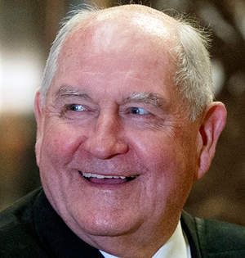
Sonny Perdue
Senate Hearing: T.B.D.
The former governor of Georgia would run a department that oversees America's farming industry, inspects food quality and provides income-based food assistance. He would also have partial responsibility to carry out Mr. Trump's positions on trade.
Secretary of Veterans Affairs
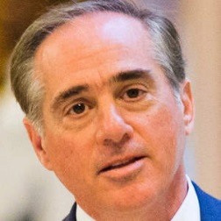
David J. Shulkin
Senate Hearing: T.B.D.
Mr. Trump has chosen Mr. Shulkin, the current under secretary for health at the agency. Mr. Trump has argued that the Obama administration neglected the country’s veterans, and he has called improving their care a top priority.

Chairman of the Council of Economic Advisers
Not yet chosen
The head of the council, who advises the president on economic policy, is typically drawn from acadamia.

White House Chief of Staff
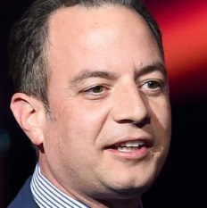
Reince Priebus
Appointed
The departing chairman of the Republican National Committee is known as a dealmaker and is close with the House speaker, Paul D. Ryan. His role will be key in a White House run by Mr. Trump, who has no experience in making policy.

Chief Strategist

Stephen K. Bannon
Appointed
Mr. Bannon is a right-wing media executive who has been criticized as representing racist views as the former head of Breitbart News. Mr. Trump said that he would be “working as equal partners” with Mr. Priebus, the incoming chief of staff.

Senior adviser to the president
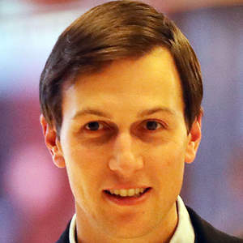
Jared Kushner
Appointed
A major developer in New York, Mr. Kushner is married to Mr. Trump’s daughter Ivanka and has been a close adviser to the president. Mr. Kushner's appointment to the senior White House role could test anti-nepotism laws.

National Security Adviser
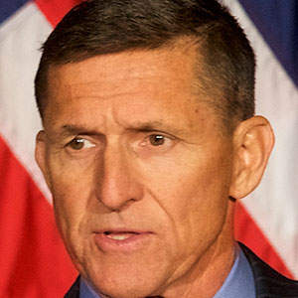
Michael T. Flynn
Appointed
The retired Army lieutenant general has been outspoken in his view of the threat posed by Islamist militants. He will be a critical gatekeeper for policy proposals from the State Department, the Pentagon and other agencies.

Homeland Security Adviser

Thomas P. Bossert
Appointed
A top national security aide to President George W. Bush, Mr. Bossert now runs a risk management consulting firm and is a senior fellow at the Atlantic Council research institution. The position will be equal in status to the national security adviser.

Counselor
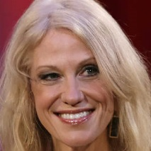
Kellyanne Conway
Appointed
Mr. Trump's campaign manager, confidante and spokeswoman, Ms. Conway also has a background in polling and may rely on these skills to keep tabs on public sentiment as she helps set the president's agenda.

Special Adviser on Regulatory Reform
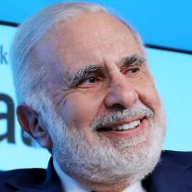
Carl Icahn
Appointed
The billionaire investor and famed “corporate raider” will oversee Mr. Trump's promised effort to unwind as many regulations on business as he can.

White House Counsel
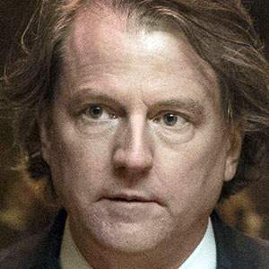
Donald F. McGahn II
Appointed
The Washington lawyer may have an unusually daunting job as the president’s adviser on legal matters, given Mr. Trump’s far-reaching business empire and potential conflicts of interest.

Director of Trade and Industrial Policy
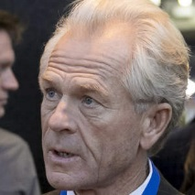
Peter Navarro
Appointed
The professor, who has been a staunch critic of current Chinese economic policies, is the only credentialed economist in Mr. Trump’s inner circle. He will direct a new internal council overseeing White House trade and industrial policy.

Press Secretary and Special Assistant to the President
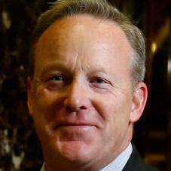
Sean Spicer
Appointed
Mr. Spicer was the longtime spokesman for the Republican National Committee and top aide to Mr. Priebus. Mr. Spicer will be the face of the White House, framing messaging, responding to stories of the day and briefing the press.

