Stagecraft
Floating Leaf Assignment
Directions: using the picture provided to you, create a world of the play. You must provide 6 pictures with text explanations. You must include 3 adjectives describing your world. Share with hibler@edisoncomputech.com by Wednesday at 7 PM. The website to see the picture in color has been provided.

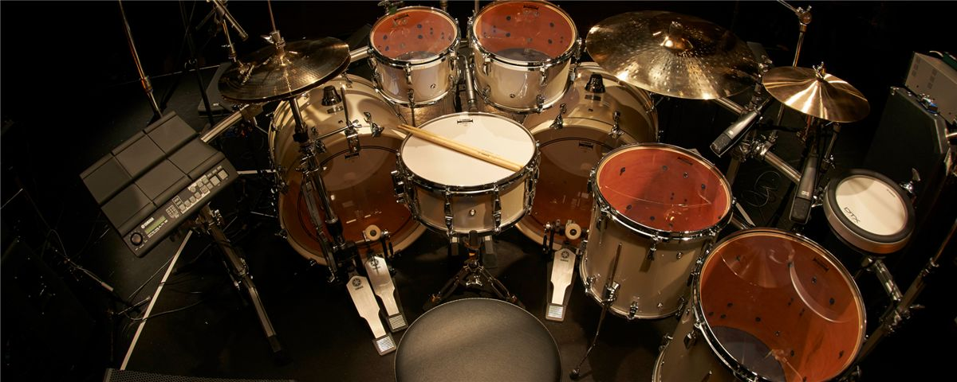
https://usa.yamaha.com/products/musical_instruments/drums/ac_drums/drum_sets/index.html

