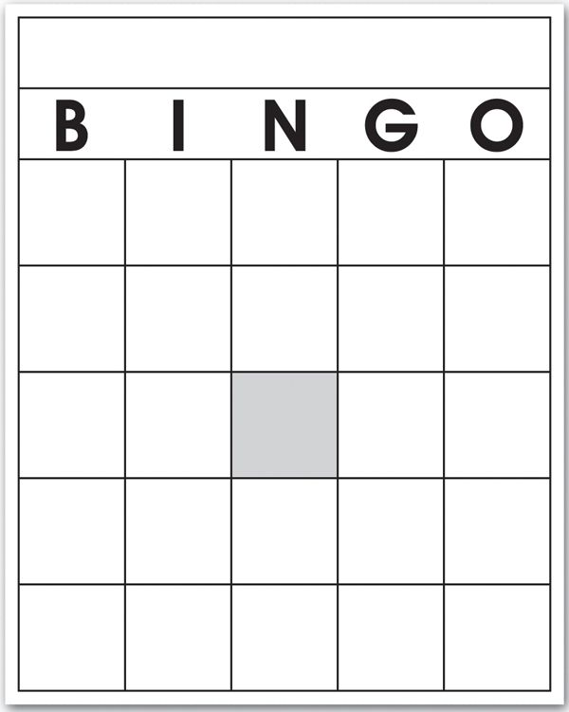
Won a trophy
Hated POI
Loved Debate
Blocked with Hibler
Said “Thank you” and walked away
Broke to Finals
Wrote a neg case
Got your “Proud Mama” pic taken
Loved your piece
Hated the topic
Spoke in Circle of Solidarity
Ate lunch in 91
Loved Speaking
Every round in the same room
Asked for ballots before Hibler was done
Loved Interp
Wore Team shirt on Thursday
Wrote a pro case
Talked to a tree
Was the last to be picked up
Learned more about your topic than you care to admit
Ate snacks before a round
Talked crap about Granite Ridge
Had a bad round
Proud Tiger Performance Artist!
CTC 4n6 Nerd

