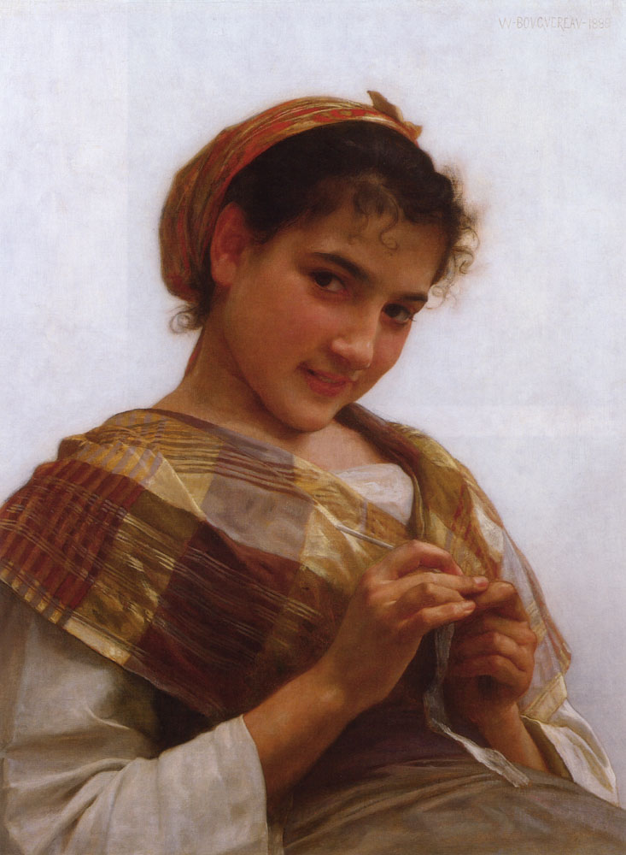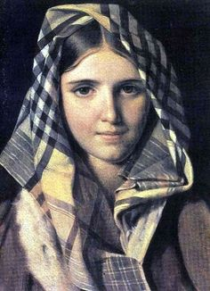

Chava is a playful girl who is not afraid to break the rules for love and independence. She loves color and texture. She won’t quietly accept life in Russia and discrimination.

My adjectives: mischievous, outspoken, fearless

Tevye and Golde’s third daughter, Chava falls in love with Fyedka, a Russian, and is ordered to “never see him again.” They elope and her family disowns her, until the end when Tevye momentarily acknowledges them.

Chava is the scholarly daughter who loves to read. She falls in love and runs off with Fyedka, a Russian soldier, and breaks her father’s heart. This role requires a capable dramatic actress who can perform an emotional dance

Chava (pronounced “ha-va” - the H is guttural) F 15-20. An introspective, rather shy young woman who seems to favor books over other pursuits. Her love for the young Russian, Fyedka, tests her father's love to the limit and provides the largest conflict in the story. The actor playing Chava must be able to display a wide emotional range. Ensemble dancing and two dances with sisters

