Rachel Hibler
Red MOTS 2018
Costume Research
Malvolio- yellow stockings style
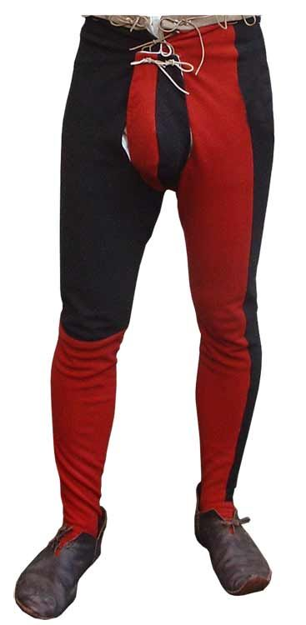

For Malvolio’s yellow stockings costume I want him to look very silly. But also, very put together. He needs to not know he looks ridiculous. I want to pull traditional stocking ideas from Elizabethan and Italian styles. Show off his legs as much as possible.
I love the legs are a bright yellow and are leggings instead of just socks.
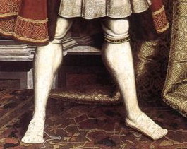
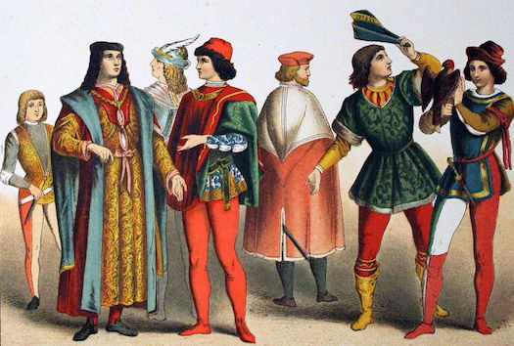
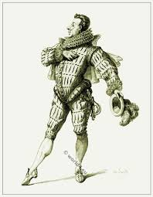
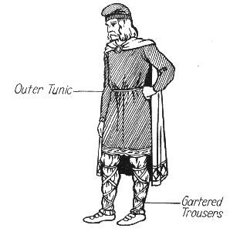
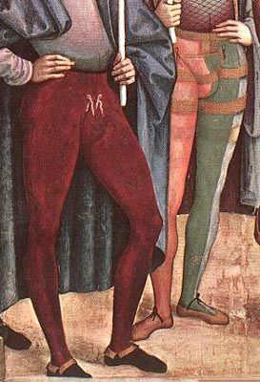
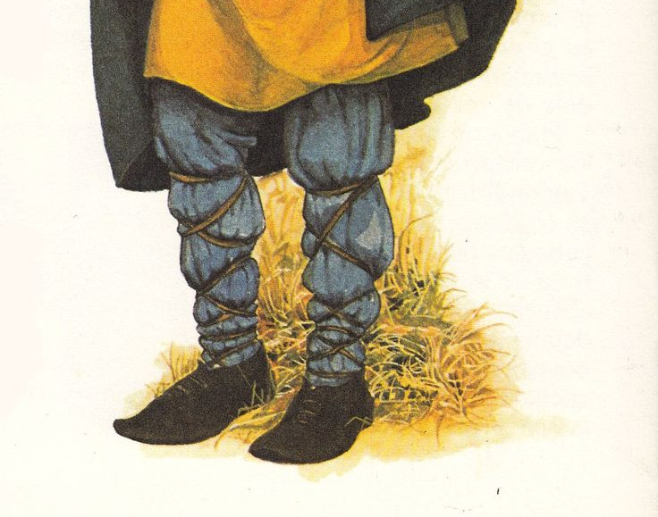
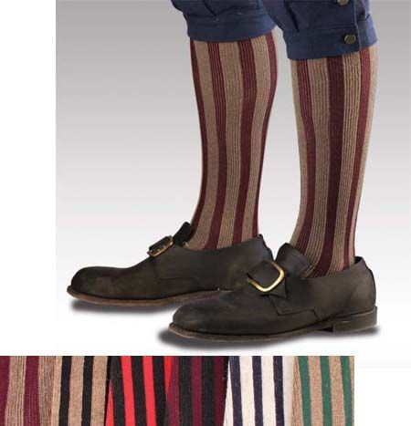
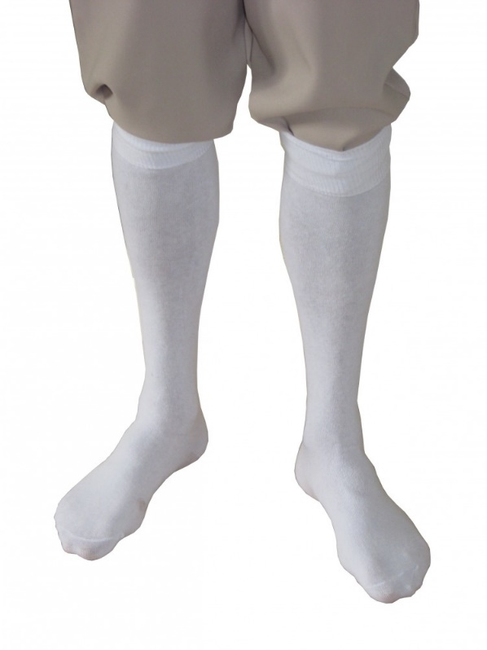
The picture on the left is how I see Malvolio strutting around in his yellow stockings style. Very sure of himself and overdressed to the max.

Below are cross gartered images. The cross gartered dates back to the Vikings and I like that he would be pulling from a deep history for that style.
I looked at Victorian stockings and they were mostly socks that go to the knee. I think I like the whole leg leggings style. Makes more of an impact. But I do love the stripes on these socks. Very fun and whimsical.

