Rachel Hibler
Red MOTS 2018
Costume Research
Malvolio

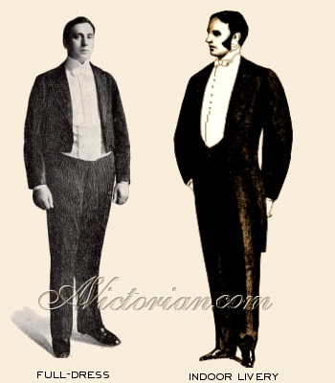
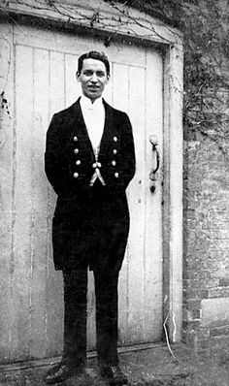

Malvolio’s servant costume needs to be fussy and impeccable. He is very into his appearance, having bought completely in to the attitude of Illyria. He wants to be someone important and perfectly kept. He has ambitions of upward mobility so everything about him is in order.

I love the Victorian valet style. Clean lines and attention to detail fit him perfectly.
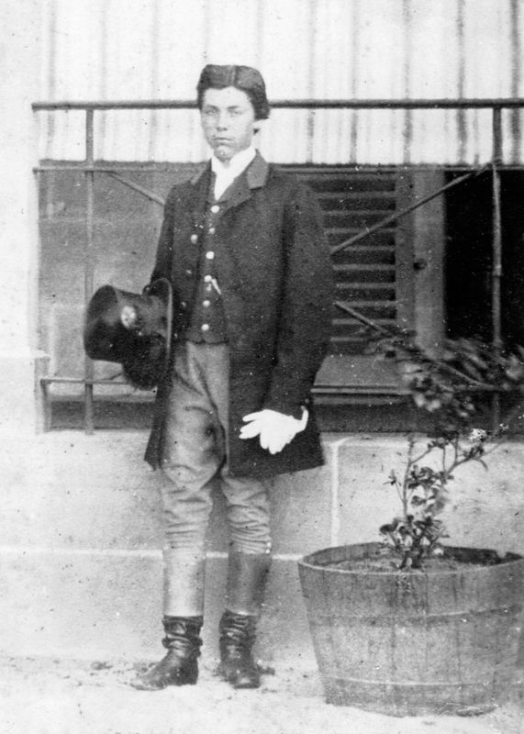
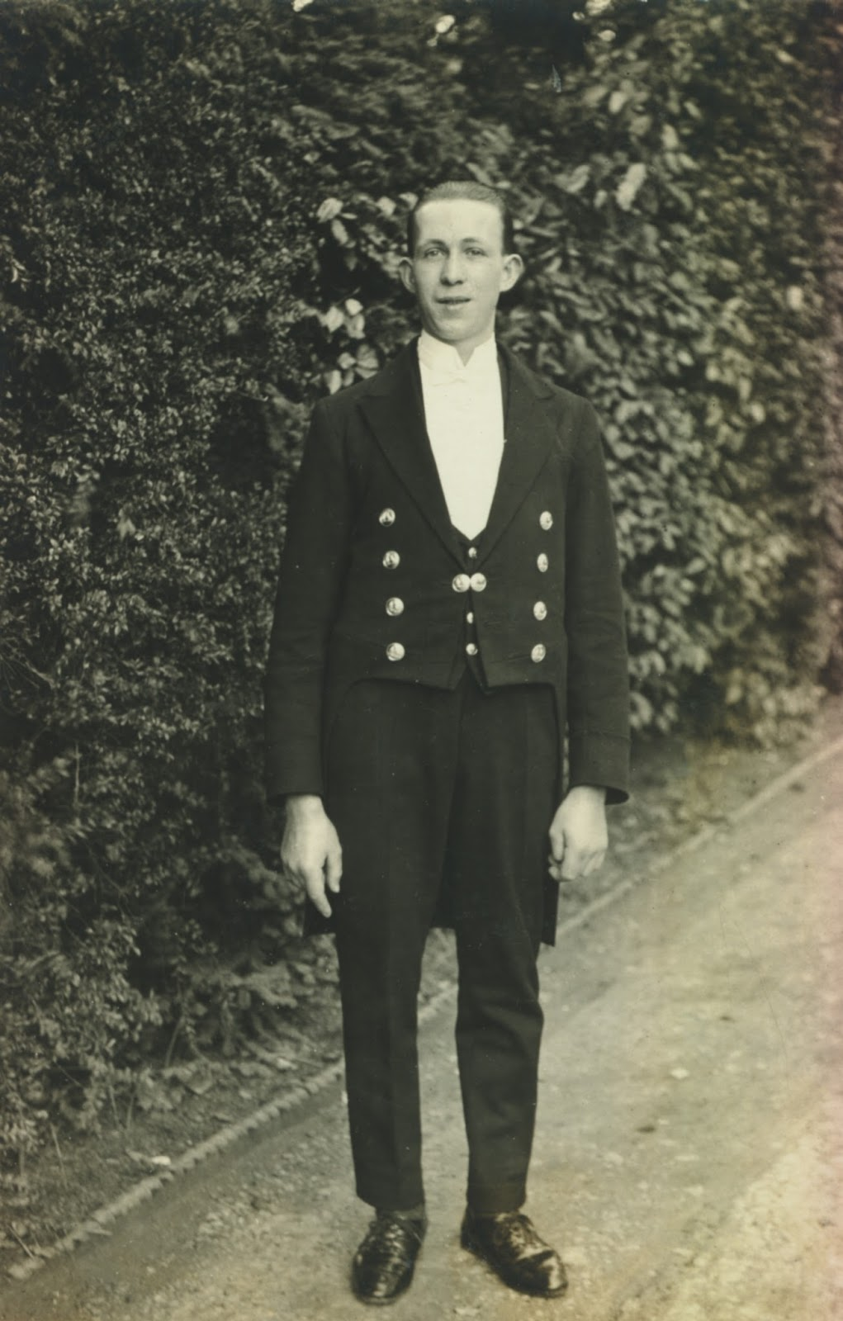
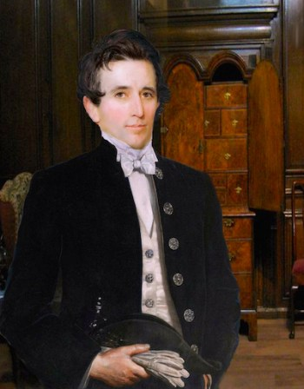
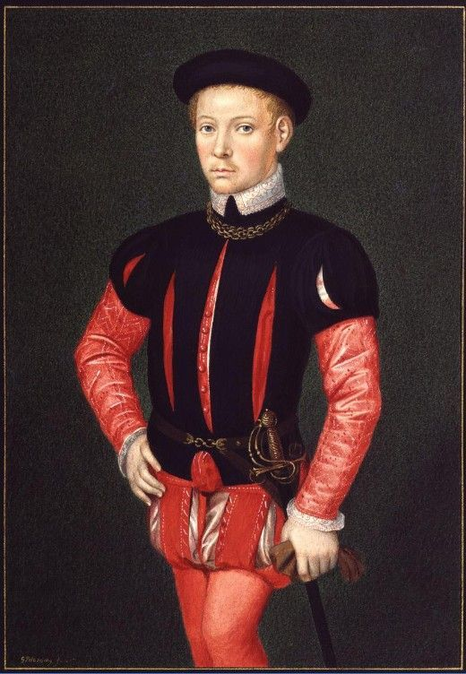
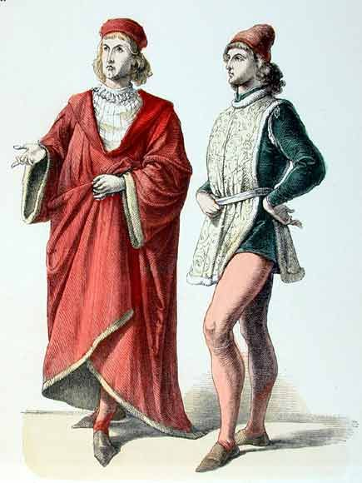


I love the details such as gloves, hat, buttons and waistcoat watch. He is very buttoned up and precise in his appearance. It is not easy to move in his clothing. The clothes keep his posture straight. I love the layers as well.
Combining the Victorian with the Italian Renaissance style works very well for Malvolio. I like the pomp and circumstance of both styles. Lots of layers and tight-fitting clothing.

