Rachel Hibler
Red MOTS 2018
Costume Research
Olivia Mourning costume
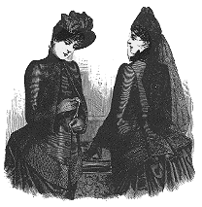

I really wanted to explore classic Victorian and Elizabethan mourning clothing for my Olivia mourning costume. I want to infuse elements from both traditions into her design. I love the long veils from the Victorians. The ruffles, bows and bustles all fit into my vision of outward grief. I want Olivia’s grief to be on display as well as still maintaining the public declaration of her wealth. I really like the hats and the gloves to finish every costume. Feels very deliberate, which is the feeling I want to evoke.

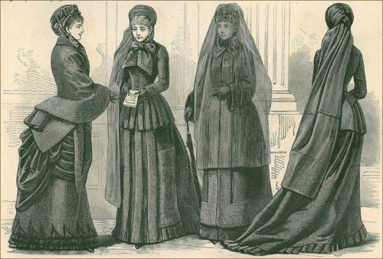
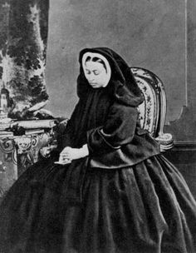
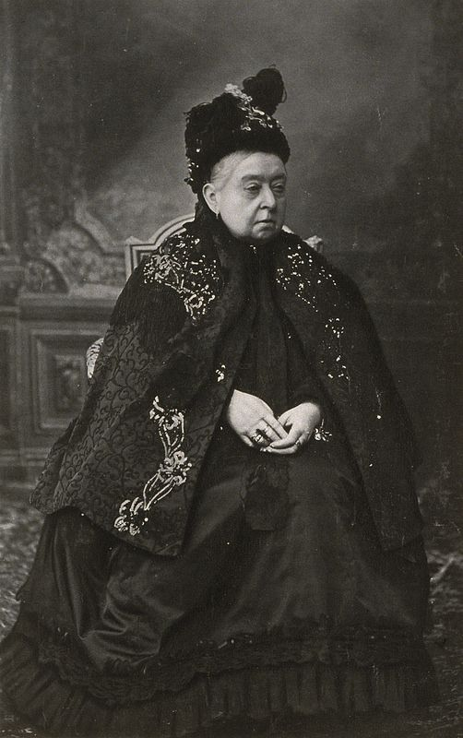
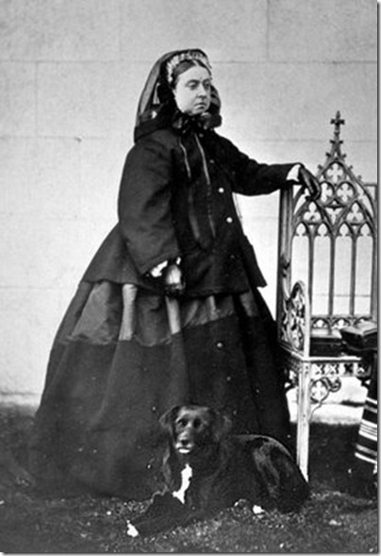
I took inspiration from Queen Victoria for the mourning dress. I don’t want Olivia to look as bulky as the queen does, but I love all the details. I like the lace detail on her cape. I love the yards and yards of fabric with ruffles. I really like her head piece with the long veil. Each dress gives a feeling of importance and stateliness. She is not someone with whom you can trifle. Olivia is trying to emulate that same feeling.
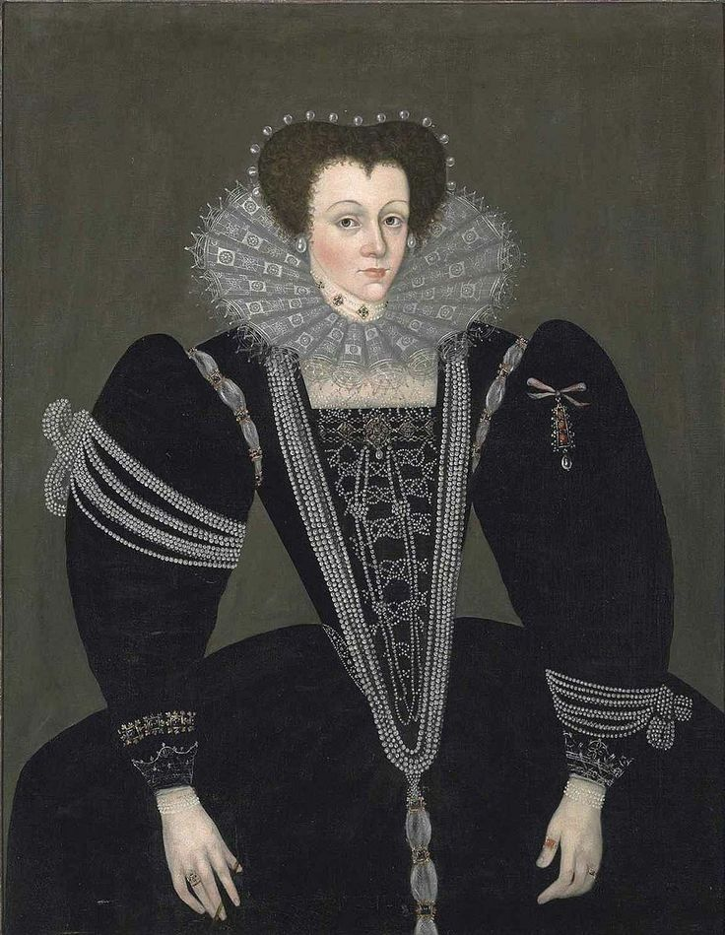
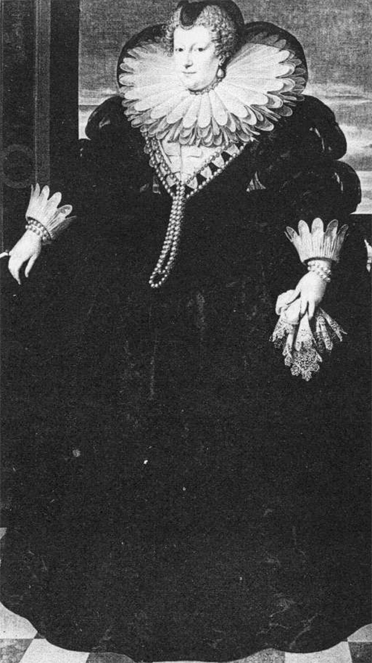
I searched through Elizabethan mourning clothing and the extravagance didn’t disappoint. Again, I love all the details. The collars, the pearls, and the handkerchiefs all add to the outward show of grief. Appearances of wealth as well as grief are equal in the eyes of the wearer.
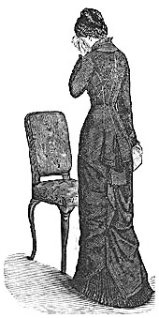
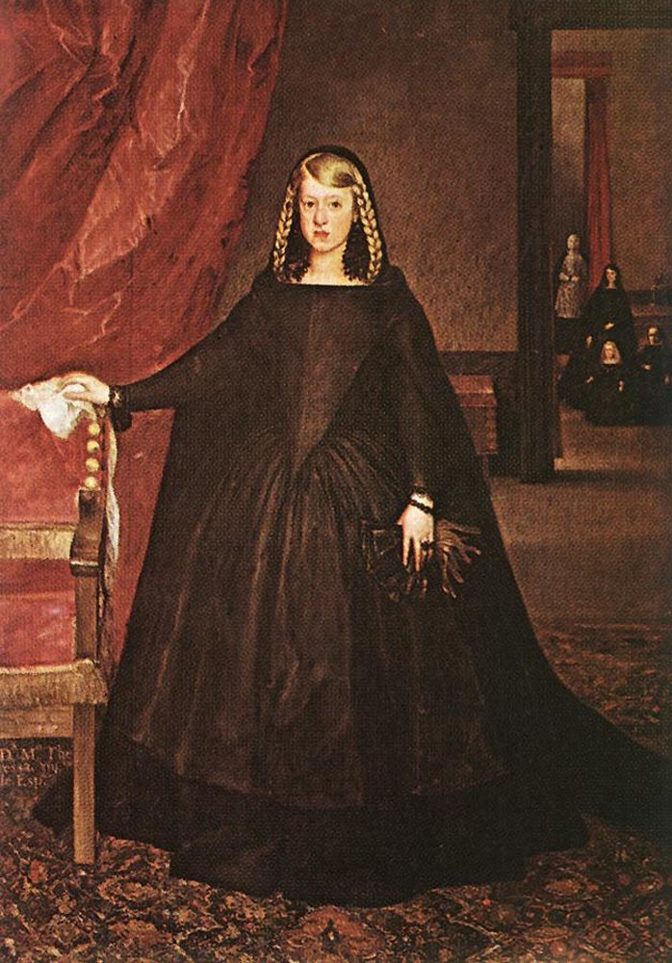
I love this portrait of a young girl in mourning. She has all the elements of what I want in my design: gloves, handkerchief, head piece with a veil, yards and yards of a gown. She isn’t getting much done today other than showing off how sad she is at her loss. This is exactly the feeling of Olivia’s design. She can be legitimately sad, but society demands she show it.

This drawing of a Victorian woman crying is the image I have of Olivia in her honest, private moments. She is turned away so we cannot see all the extravagance of her gown, instead all we see is her pain and thus a real person.

