Blocking 101: How Directors tell stories with movement
By David Vegh, “Dramatics Magazine”
AS A DIRECTOR, you are first and foremost a storyteller. Your goal should be to tell the writer’s story clearly and effectively, with as much specificity as possible. What tools do you have at your disposal to achieve this?
In plays, with few exceptions, the primary way the audience follows the story is through dialogue. In musicals, the music, lyrics, and choreography also reveal aspects of character and further the plot. Your design elements are effective storytelling tools as well.
The other major tool you have at your disposal is the blocking, also known as staging. This includes not only how characters travel from one place to another onstage but also their spatial relationships to one another. Here are several fundamental considerations when blocking a play.

ESTABLISHING CHARACTER RELATIONSHIPS
Imagine you are sitting on a park bench next to a stranger. How physically close are you likely to sit? Now imagine that person is your best friend. Does the physical relationship change? Do you sit closer? Is it possible your arms or shoulders may touch when you laugh together or recount a shared experience?
Now imagine this person is a romantic interest. Does the physical relationship change again? What if it’s a first date, and you both are incredibly nervous? What if this is your three-year anniversary? By making specific choices about the comfort level between characters using proximity and physical contact, you help the audience understand aspects of their relationship the dialogue may not reveal.
When students bring prepared work to my scene study classes, I’m continually surprised when they inevitably stand about two feet from each other throughout most of the scene. The problem with two feet apart is that it doesn’t really communicate anything about the relationship. It’s neutral. It might work for two people who barely know each other, but, even then, it tends to look stagey and boring. Tell us how the characters feel about each other through their spatial relationship. If a character walks onstage, makes eye contact with their ex, then makes a sudden beeline for the other side of the room, that denotes something significant. And it’s dramatic. As an audience member, I’m immediately intrigued by how this scene will play out.
Spatial proximity can reveal a lot about character relationships, like the friendships among Molly and the orphans in Peter and the Starcatcher.

REVEALING CHARACTER THROUGH MOVEMENT
Characters move for different reasons. The most basic is to travel from one place to another with a specific purpose. They’re thirsty and want a glass of water. The baby is crying, so they go nurse it. That said, if your characters ONLY move when they have a specific need or destination, there will be very little movement in your play, and it will feel static.
The larger the playing space, the more evident this becomes. You need to discover and motivate stage movements for actors that might not seem completely natural. How do we do this without coming across overly stagey, or worse, arbitrary?
In addition to coming up with activities for your actors and places for them to go when devising the ground plan for your set, explore ways to reveal the psychology of your characters through blocking. By this, I mean how they feel about the other characters onstage at any moment. One rule of thumb you can use is to have characters move toward things that bring them pleasure and away from things that cause them pain. My boss just offered me the promotion I’ve been hoping for. I move toward her excitedly, closing the gap between us. My father just said I’ve been a terrible disappointment. I turn away from him, dejected, toward the other side of the room. Imagine you are watching the play with the sound turned off. Could a hearing-impaired audience member still understand the relationships and follow the story by what they see onstage?
In general, actors love confrontation. These are the juicy parts of the scene. Choose a scene with a verbal fight and, left to their own devices, actors will inevitably end up four inches apart, shouting in each other’s faces. Real people, on the other hand, tend to avoid confrontation. Try staging your characters with some distance between them during a verbal confrontation, and you’ll be surprised by how much more authentic the scene feels. Also, in my experience, it allows the scene to escalate naturally. Once the actors are in each other’s faces, they have nowhere else to go emotionally.

CREATING DYNAMIC STAGE PICTURES
While more realistic aspects of your blocking will be informed by character behavior and psychology, you want to consider balancing this approach with moments that create aesthetically compelling stage pictures. Experiment with variations in spacing and composition. This can be particularly useful when you want to focus a pivotal story moment. Stand at the back of the house so you have some perspective and observe your stage pictures. Are they compelling and pleasing to the eye? Is the visual point of focus clear?
A basic approach to creating more dynamic stage pictures is to play with angles. Characters on an angle almost always look more interesting than those on the same plane. If you are working on a thrust (audience on three sides) or arena (audience on four sides) stage, keeping actors on the angles is vital for audience sightlines. Imagine you painted a giant “X” on the floor that reached all four corners of the stage. If you keep performers on the imaginary paint, it will help your audience see every actor’s face.
Use the fourth wall. Placing something imaginary on the fourth wall (for example, a window or a special view in an outdoor setting) that gives characters a reason to move downstage opens blocking opportunities, as actors will be able to speak without turning their backs and upstaging themselves.

DETERMINE YOUR FOCAL POINTS
In film, when the editor wants the audience to focus on something important, they cut to a close-up shot. In theatre, the audience is free to look wherever they want. As a director, your job is to help guide the audience and focus their attention.
As you analyze the script, make notes about what you believe are the most important moments in each scene, and compose your stage pictures with them in mind. Never take for granted that the audience will look where they are “supposed” to. Guide them, and they will appreciate it.
Playing with angles and levels can add variety to your blocking and improve audience sightlines.

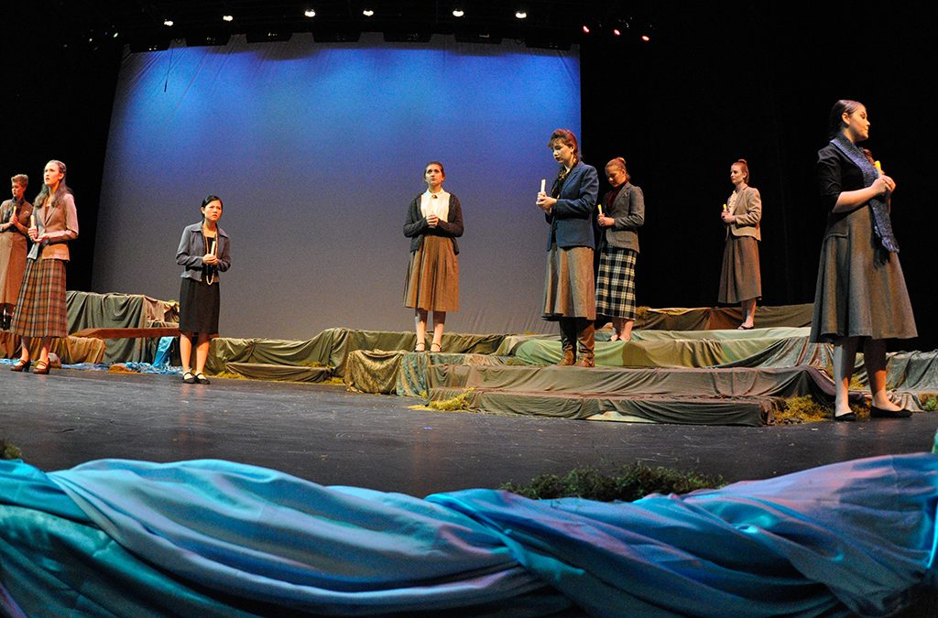
GENERAL BLOCKING TIPS
Variety is the spice of life. You are constantly battling the waning attention spans of a screen culture. Vary your stage pictures. If it makes sense with the scenic design, adding levels to your set can help.
Use as much of the stage as possible over the course of the play, and don’t confine any character to one part of the stage without a compelling reason. Family members sitting far house left will be disappointed if the actress they came to see was on the opposite side of the stage the entire performance.
In general, characters in plays tend to stand more than in real life, where it is more natural to sit. This is to keep the energy up for both actors and audience. This is not to say that characters should never sit — of course they should. Just find ways to mix it up.
Know when NOT to move. The play’s dialogue is the primary way the audience follows the story. Any time someone moves, it draws attention, because audience members assume that character is moving for an important reason. This momentary distraction might mean they miss a pivotal plot point. If essential information is being communicated, or if the language is dense or poetic and requires more concentration (such as in a Shakespeare soliloquy), stillness is generally your friend. Use movement to punctuate beat transitions in the scene instead.
Finally, in blocking rehearsals, repetition is everyone’s friend. I like to give actors three to four blocking moves, then run that small section of the scene at least twice before moving on. This will help them cement the blocking, as well as give you the opportunity to see what’s working and what isn’t. Leave plenty of time for repetition when scheduling blocking rehearsals.
Blocking is far more than an excuse to arbitrarily move actors around the stage. Used correctly, blocking is a powerful tool that defines character relationships and communicates key story details.

