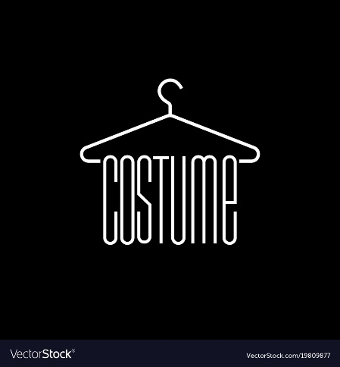

Senior Slide show!

Class awards!

Red carpet!

**When:** Friday, May 26  
**Time:** 7 PM  
**Where:** The Historic Audra McDonald Theater  
**Who:** All students enrolled in RSA Costume, Stagecraft and Theatre classes  
*Formal dress encouraged and celebrated!*

Honor our parents!

The Teddy Awards

Show awards!

You are cordially invited to…