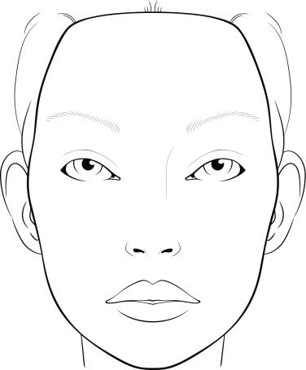

Actor Name:

Character Name:

Show:

Gender: