Auditions!
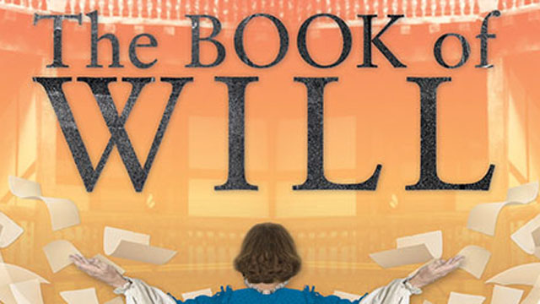

Audition dates: Monday August 21, Tuesday August 22
Callbacks Wednesday August 23

The Final Rose- One Act
Audition dates: Thursday August 24, Friday August 25
Callbacks Wednesday August 31
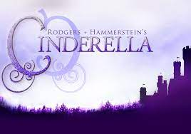

Audition dates: Monday August 29, Tuesday August 30
Callbacks Wednesday August 31

