How to Audition
Dress Code
- Never come to an audition in jeans and a t-shirt or tennis shoes
- Hair clean and pulled back, away from your face
- Always dress professionally
  - Ladies should wear skirts or dresses and character shoes (heels)
  - Gentlemen should wear slacks, a button up, a tie and jacket
  - Darker colors preferable
Preparation
- Be at least 20 minutes early
- Have a headshot with your resume printed on the back
- Always have a 1-3 minute monologue ready to perform
  - Have a clean copy of the monologue for Casting Directors
- Have an introduction prepared
  - Your full name
  - Your age
  - The piece you are performing (title and author)
  - The part for which you are auditioning (if applicable)
Behavior
- Be professional
  - shake hands
  - smile
  - do not interrupt or suck up
  - come ready to work
  - be sincere
  - listen
- Always use the stairs to mount the stage
- Learn the names of all Casting Directors
- Know the project for which you are auditioning
  - title
  - author
  - director
  - read the script before you audition
- Wait until instructed to begin
- Never complain about any performance (yours or others)
- Provide sincere congratulations and applause for all performers
- Lower head before and after the monologue to indicate performance beginning and ending
- Wait to be dismissed
- Say “Thank you” before you exit stage
- Never ask to perform again
- Enter the room with certainty and confidence
- Never make excuses, accept criticism silently
- Try to be the first to audition, casting directors are tired by the end of auditions and may not pay attention to you
- Never stop and restart, keep going.
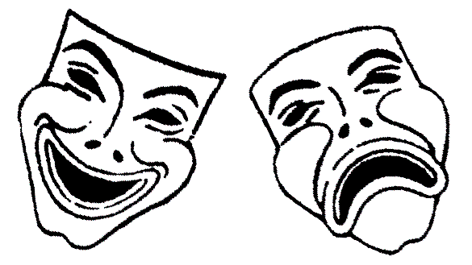
- If you forget your monologue, jump to the next part you remember. No one will ever know!

