
Props
Lead Grace Jerkovich
Salem Lazalde
Bennett Jones
Costumes
Lead Izzy Valdez
Ryah Finch
Cienna Harris
Bennett Jones
Leonardo Martinez
Jasmine Puentes
RSA Costume Class
Wigs/Hair/Makeup
Lead Vyni Ramirez
Yusdely Vivar

Lights
Jaqueline Garcia Vidrio
Sound
Lead Adamaris Chilero
Esabela Avila
Bennett Jones
House
Lead Charlotte Wiens
Kamilla Albarran
Rosseline Castillo
Syd Galaviz
Berenice Lopez Reyes
Set
Lead Jonathan Giometti
Hocking
Layla Sanchez
Joseph Pruell

Crews

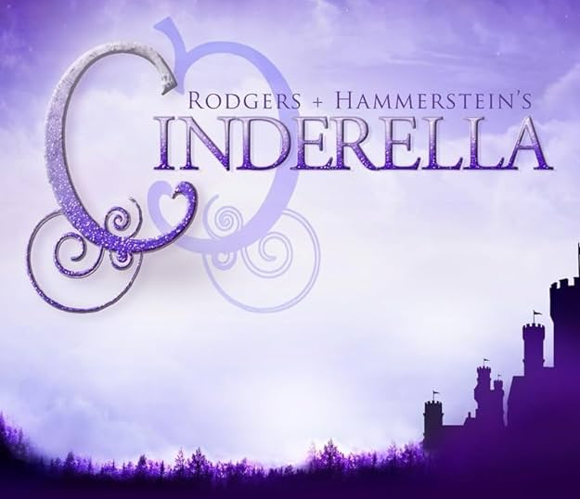

The Roosevelt Theatre Company is, first and foremost, a LEARNING LAB. We believe STUDENTS can and will lead Production and Design under the mentorship and guidance of Industry Professionals. RTC is about taking risks, making fearless choices, and training life-long artists. RTC is about experiencing how the professional theatre industry operates in each of its sectors. RTC values leadership, accountability, teamwork, responsibility, and creativity in a safe and supportive environment.

Directed by Niko Ramos
Cinderella is produced in agreement with Concord Theatricals
proudly presents
The Roosevelt Theatre Company Mission Statement

Produced by special arrangement with Music Theatre International

