Daniel Mejia (Topher) is in 11th grade in Theatre Styles. Previous RTC show credits include The Book of Will (US Henry Condell), The Final Rose (Jeremy), The Trysting Place (Rupert), 12 Incompetent Men (8), Something Rotten! (Nigel Bottom/US Shakespeare), The Plot, Like Gravy, Thickens (Roy/US Hollister), Check, Please (US Ken, Dewey/US Lyle), The Dedication (Johnny Pinedu), and Sorry, Wrong Number (George). He would like to thank “my family for supporting me and all of my fellow Company members and Advisors for making my experience in theatre a great one!”
The Roosevelt Theatre Company would like to thank our wonderful Alumni, Joel Abels, for his support, expertise, and beautiful design on Cinderella.
Cast Bios

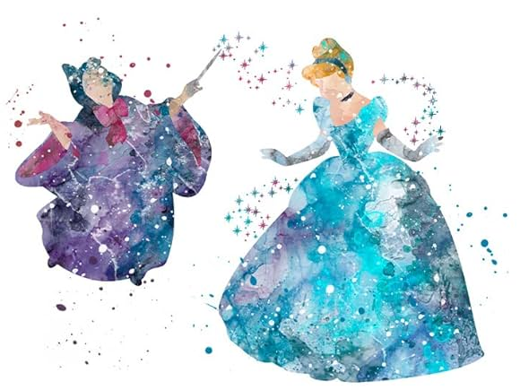

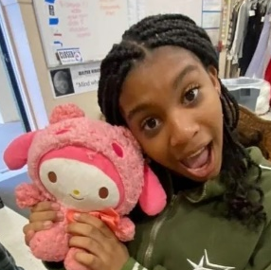

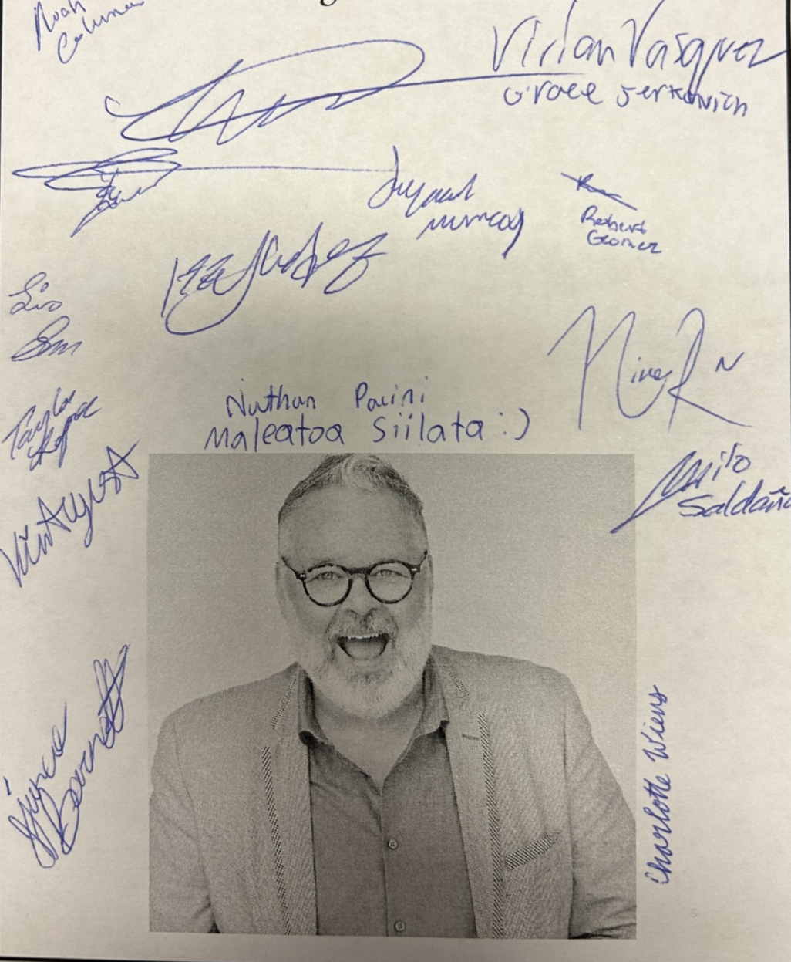
Joycelyn Murray (Ella) is in 9th grade. Previous RTC show credits include The Book of Will (Production Assistant), The Butleress (Charlotte) and 12 Incompetent Men (7) Other shows include CMT’s production of Chicago Jr. (Annie), and Bullard TALENT’s productions of Shrek Jr. (Ensemble) and Little Mermaid Jr. (Atina). She was most recently seen onstage in GCP’s production of A Christmas Story. She would like to thank “7/11 for making sure I’m fed every day before rehearsal. I would also like to thank Kathy for taking me home every night after rehearsal.”

