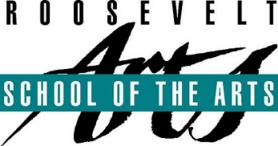

Schedule for this evening



Since September 1984, Roosevelt School of the Arts Magnet program has provided 9 through 12 grade students with in-depth specialized training in the performing, visual and media arts while offering a rigorous academic program. All our shows are conceptualized and designed by students under the training of Advisors and Theatre professionals. Everything you see on the stage is intended to be there and was part of a decision and design made by a student for telling their story. Nothing you see on stage is an accident. We try to let students do as much as possible.

One of our goals is to educate our audiences as well as students on how to be consumers of Theatre. Cinderella is such an enduring tale, every culture in the world has some version of the story, so the challenge becomes how do we make it new and interesting for a modern audience? And we found the answer in our very own Crazy Marie: the magic and music in each of us. As we grow up, we tend to lose our sense of wonder and belief in the impossible. Student director Niko Ramos’s concept for Cinderella was as if a children’s book jumped off the page and came to life. Our two words of inspiration for the show were: dreamy and magical. We wanted to transport our audiences back to their childhood; to a fairytale land of charming princes, magical fairy godmothers and dreams coming true.

We invite you to let your imagination run free as you step out of your own little corner and are cordially invited to our Royal Ball. Who knows? Maybe your impossible dreams are possible after all!

Act 1

20 Minute Intermission  
*Refreshments and merchandise sold during Intermission.*

*FRSA raffle during Intermission*

Act 2  
Post show pictures and autographs with cast and crew

**Please NO food or**

**drinks in the**

**auditorium**

Welcome- Director Niko Ramos

*Please no recording or taking pictures during the show*