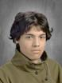
“It’s not a hard show, it’s just a big show,” has been my repeated mantra for the entirety of Cinderella’s production. I have never attempted such an enormous show before, and I produced Fiddler on the Roof with middle school students! Every aspect of this show is big. The story is big. The characters are big. The audience expectation is enormous, I mean, you can’t do the show without a carriage and an on-stage dress transformation, or the audience will start throwing tomatoes. (Don’t worry, you’ll get both, so put your tomatoes back in your purse). However, when I take a step back and strip away the spectacle and the grandeur, I see a simple story about a girl who wants what we all want: a happy life. Often in this life we get distracted and overwhelmed by grown up responsibilities and we easily overlook the quiet messages of hope, happiness and the simple joys of having family and friends around us.
Our goal as performance artists is to always tell the story and Cinderella is such an enduring, universal story that it seems fitting that would be the story we told this year as we settle into the second year as The Roosevelt Theatre Company. In fact, I’d say we’ve had our own Cinderella story as a Company as we’ve had to pull together more than ever to solve problems while staying positive and seeing the magic in each other. Not to mention, after the delightfully irreverent and blush inducing Something Rotten!, Archer told me I had to give her a “hard G” this year! This year has been quite challenging from the demanding shows we’ve produced but our Company has risen to the challenge and I’m so proud of the theatre we have put in front of our audiences.
I must thank my amazing support system of Advisors: Randy Kohlruss, Kirby, Serena Rimorin, Emma Raymond, Richard Woods, Taylor Ledak, Harley Alvarado, and Joel Abels. Thank you for your patience, expertise and being such a wonderful influence on our kids. Thank you to my RSA Admin, Brooke Archer, who never misses an opportunity to ask, “What do you need?” Thank you to my dependable parents who never show up empty handed, and I can always count on to be here on the weekends, or any time I need you. I’m so lucky to work with your kids and have you take such an active interest in their theatre program. Thank you to my family and friends for their love this year. Huzzah!
-Rachel Hibler, Show Advisor
Leonardo Martinez (Costume Crew) is in 11th grade in Costume Design.
From the Advisor

Crew Bios


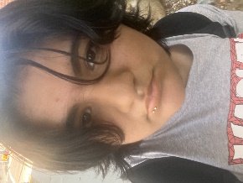
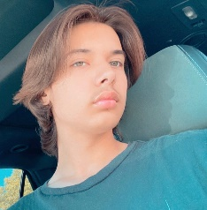
Joseph Pruell (Set Crew) is in 12th grade.
Jasmine Puentes (Costume Crew) is in 9th grade. Previous RTC show credits include The Book of Will (Costume Lead) and The Final Rose (Costume Crew), CTC’s productions of A Year with Frog and Toad Kids (Props Crew), Fiddler on the Roof (Props Co-Lead) and Alice in Wonderland (Props Lead). She would like to thank “*NSYNC rules! #tearinupmyheart”
Niko Ramos (Director/Topher Swing) is in 11th grade in Theatre Styles. Previous RTC show credits include The Book of Will (Stage Manager), Living in Oblivion (Chad Palomino), Something Rotten! (Bard Boy), The Plot, Like Gravy, Thickens (US Walter), Check, Please (Hank), and The Dedication (Kyle). Niko was also seen on stage in Peter Pan Jr (Michael), and Wonderland (White Pawn). He would like to thank “my family and friends that have supported me along my journey. And my mom and dad for everything they’ve done for me. And Taylor Swift!”

